Lesson Planner

Lesson plan for: Components Theory 1 |  |  | No: 5/12 | Date: 6/5/03
Year: L6th | Group: Revision | Room: Class 1 | Time/duration: 55min

Summary of previous work and focus of this lesson
Students have completed major project work and are now covering theory required for AS exam paper. This is to cover Unit 3 Section A (R301) Materials, Components and Systems over twelve lessons.
This lesson is to introduce aspects of components used to join materials and translate motion or energy from one form to another.
Objectives
Teaching Inputs: Pupils will learn about:
Explain different nuts/bolts with thread types, theory of thread cutting and other joining methods (rivets)
Explain gears, bushes and cams
Introduce stock sizes to inform designing
Learning Outcomes: By the end of the lesson pupils will be able to do or do better:
Respond to Q&A during lesson to confirm understanding of components
Work during prep to consolidate information and self test using text book tasks and practice exam questions on handouts

Links to: Literacy/Numeracy; Citizenship; SMSC development:
SMSC – consider effect on society in choices by designers on whole of life issues – issue of reuse or ease of disassembly
Citizenship – working together to revise content => co-operation

Resources required and risk assessment:
Teacher
Marker Board & Pens, Textbook

Students
Textbooks, notepads, pencils
Risks
Minimal in classroom environment

Time/section | Activities, key teaching points, health and safety points
5 min  15 min  5 min  5 min  5 min  5 min  10 min  5 min | Standard Operating Procedures –Take Register.  Establish good order – No chewing, coats – shirts and ties  Outline purpose of lesson on components to include nuts/bolts, thread cutting, rivets, gears, bushes and cams.  Requires continuous feedback to ensure all topics are covered or recovered as necessary ready for exam  Screw threads P 77 + P282-284  Three uses  - Convert rotary to linear motion  - Obtain mechanical advantage  - Fastenings  Mechanical advantage due to inclined plane  Four types of thread  - v-thread fasteners due to friction between flanks and nut  ISO metric => dia. & pitch in mm (coarse or fine)  older forms are BA, BSF, BSW, UNC & UNF  - square moving parts in m/c/ lifting jacks – not as strong as vee  less friction than vee but accepts large force  - buttress force in one direction only e.g. woodworking vices/quick release  - acme motion via engaging nut – tapered sides allow easy engagement  of split nut on screw thread e.g. centre lathe  External thread cutting using split die and die stock  Internal thread cutting using tap and die  Drunken thread is when die is not square to axis of rod  turn 1 cut + ½ reverse to break swarf  Taper rod to allow thread to start cutting  Single point cutting also possible using center lathe  Nuts and bolts  Low to medium carbon steel – forged or machined threads my be cut or rolled  May be galvanized to inhibit corrosion  Alternative is coach bolt or stud.  Use handout on nuts and bolts to illustrate common forms  Rivets are a quick and convenient method of permanently fixing two or more pieces of material normally sheet metal. Cheap alternative to threaded fastenings which may be grouped to form rigid joints or act as a pivot/ hinge pin.  Cams P273-276  Convert rotary to recriprocating motion via cam and follower  Gears P78 + P158-160  See handout for different gear arrangements  Toothed wheel with special profile for transmitting forces and motion  2+ gears = gear train with velocity ration proportional to no. of teeth  idler gear used reverse or mainatain direction  gears may achieve large speed reductions  Bearings and bushes – radial & axial P79  Note lubrication – in special environments nylon or other plastics used in lieu of oil for plain, roller or ball bearings  Bush is cylindrical sleeve fitted into hole as bearing surface => very high forces + use of sintered materials such as phosphor bronze with low friction plus gaps for lubrication (phosphor bronze is a ‘white metal’)  Stock Sizes P79  Use handout to give pictorial view of stock sizes  Designers need to note standard stock sizes  e.g. sheet manuf. board 8’x4’ (2240x1220) or 4’x2’ (1220x610)  Ceramics filler  Glass, Concrete / Bricks, Tiles, sanitary ware  Good heat, pressure and chemical resistance but brittle/hard & not ductile  Use textbook on P76 to explain glass production on tin, plus ceramics made from clay, sand or feldspar (aluminum potassium silicate)  Start to finish off ready for dismissal. Praise effort for work done and focus forward to reviewing industrial processes next lesson.  Prep required –  Answer questions on handouts  Self check table on handout  Identify revision needs and let teacher know any specific requirements  Revise hand & commercial processes section  Standard dismissal process, stand behind chairs, quiet and leave.

Lesson Evaluation

Date: | Group: | Time/duration:

Pupil response
Sufficiency of subject content
Appropriateness of teaching methods
Achievement of learning outcomes
Achievement of trainee targets
Trainee targets for next lesson
Follow up of individual pupils
Equipment/materials for next lesson

Materials,
Components and Systems

Fixings & Stock Shapes

Name
House
Date

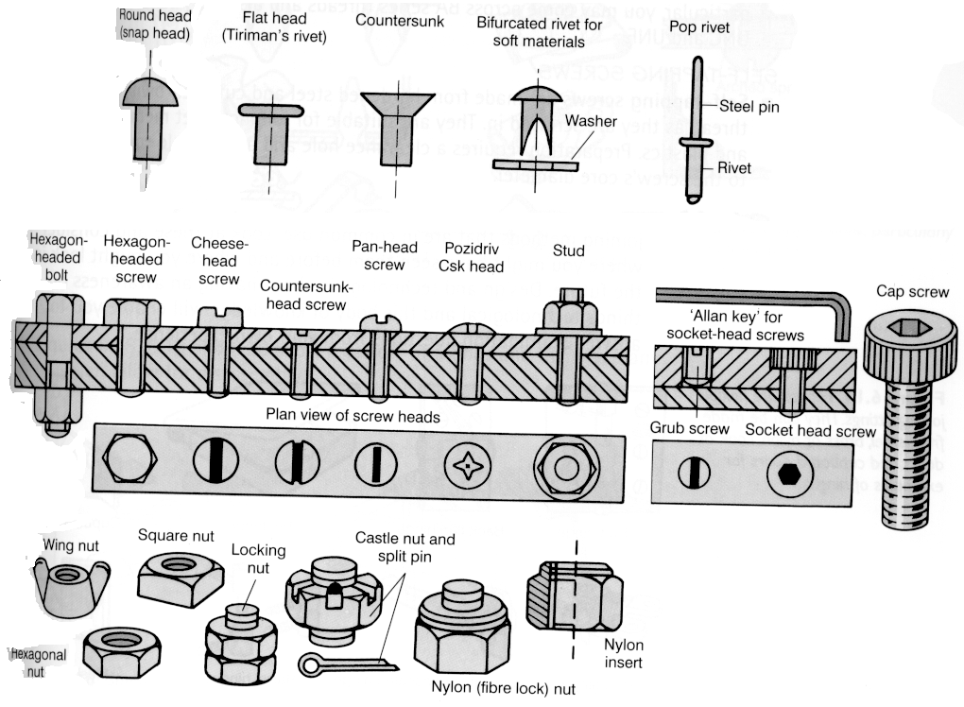

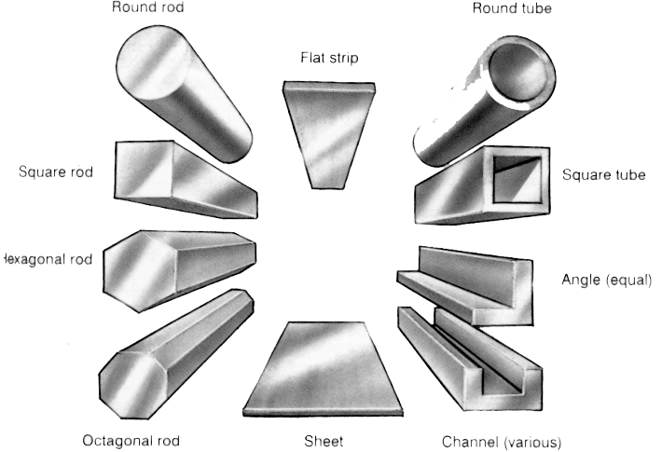
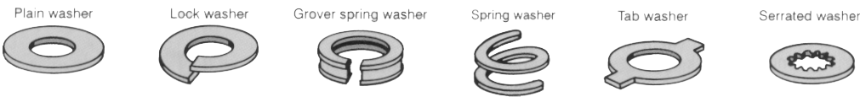

Name
House
Materials,
Components and Systems

Gears and Threading
Date

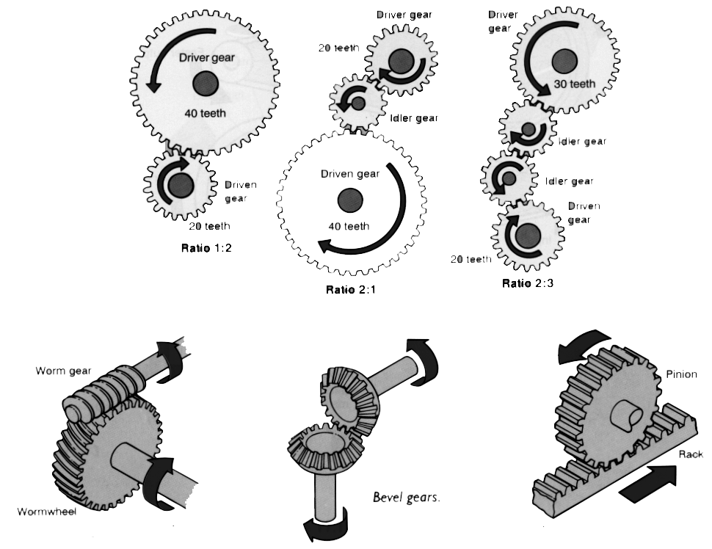

Complete the following paragraph by inserting the correct terminology as required:
tap wrench, taper, plug, square, clockwise, split die, anticlockwise

Firstly, the correct sized hole should be drilled. The tap is then held in the _________. The ________ tap should be used to make the first cut followed by a _______ tap. The tap should be wound in slowly making sure it is _________ to the hole. Each _________ turn should be followed by a half turn in the opposite direction to break the swarf. If tapping a blind hole a _____ tap should be used. when threading a ____________ is held in the die stock. A taper should be filed on the bar being threaded to help the cutting process start. Dies are used in a similar way to the taps, a turn clockwise should be followed by a turn ___________.

Questions :
- Explain the main difference between a bolt and a machine or set screw
- What advantages does a wing nut have over a normal hexagonal nut

