Lesson Planner

Lesson plan for: Brief , Design Cycle and Ideas |  |  |  | No: 1/36 | Date:
Year: 10 | Group: Hand Game | Room: Class | Time/duration: 1 hour

Summary of previous work and focus of this lesson
This is the first lesson in this module which is to design and make a hand held electronic game which will be used as a vehicle to practice the layout of a design folio demonstrating all aspects of a design life cycle.
This lesson is to explain the nature of the activity over the following 12 weeks with clearly defined assessment criteria and deadlines, explore a design cycle and map out initial ideas on hand games
Objectives
Teaching Inputs: Pupils will learn about:
Introduce project requirements using criteria assessment sheet as a basis to focus on key requirements and reinforce idea of deadlines. Layout of design folio using template borders with first initial ideas sheet
Reinforcement of design process model noting that other holistic sequences are valid;

Introduction to product analysis concepts to direct initial ideas

Learning Outcomes: By the end of the lesson pupils will be able to do or do better:
All Students will describe brief in own words and contribute to discussion on product analysis

Start to lay out folio work with initial sheet to include title and mind map of initial ideas about travel game product, brief and design cycles

Appreciate 1st deadline for completion of research work in three weeks!

Links to: Literacy/Numeracy; Citizenship; SMSC development:
SMSC – consider implications on society leisure time with advent of personal electronic games.
Literacy – Use of vocabulary to express concise and meaningful product analysis
Citizenship – Group interaction during mind mapping exercise and discussions about criteria

Resources required and risk assessment:
Teacher
Exemplar Brief and Specification, Marker Board & Pens,
Blank A3 folio template sheets, handout on life cycles

Students
Research folders, pencils, rulers,

Risks
Minimal in classroom environment.

Time/section | Activities, key teaching points, health and safety points
5 min  10 min  15 min  25 min  5 min | Standard Operating Procedures –Take Register.  Establish good order – No chewing, coats, hats, etc.  Outline purpose of this lesson to start a new and exciting project buiding skills necessary for GCSE coursework  Hand out assessment guidance sheet for front of folio and blank template border  What is a brief? – “Statement of intent” short sentence  All to write their version of brief for hand held electronic game following assessment sheet guideline  Hand out design process worksheets for reference  Work through two example design life cycles focusing on classic but also include different ‘V’ model often used for software/ electronics. Use example folder to illustrate points – students to note cycle on initial ideas sheet with brief.  Interactive stage for students to compose initial ideas about a hand held game however this is to be ‘lead’ by injecting key aspects that should be considered during product analysis and initial ideas  Students to now discuss in small groups aspects of their initial product ideas and analysis of products using resource sheet and may use the following headings to start the process  This stage allows individual attention to ensure all are proceeding in same direction and understand task ahead and resolve individual questions  Homework: ask others to help complete initial ideas list and product analysis headings – note in homework diaries that research to be complete in three weeks!  Start to finish off ready for dismissal. Praise effort for work done and focus forward to completing research on Friday.  Quick Q&A for definition of brief and life cycle  Standard dismissal process, stand behind chairs, quiet and leave.
  Classic | V model
  Brief
  Research | Requrements defines Acceptance test
  Initial Ideas | Specification defines System test
  Development | Prelim Design “ Integration test
  Specification | Detail Design “ Unit test
  Making | Manufacture
  Testing
  Evaluation (continuous)
  form versus function | Safety
  quality of design, including safety | Aesthetics
  quality of manufacture | Performance
  value for money | Ergonomics
   | Storage
   | Materials / Manufacture
   | Use / Durability
   | Cost / Maintenance

Lesson Evaluation

Date: | Group: | Time/duration:

Pupil response
Sufficiency of subject content
Appropriateness of teaching methods
Achievement of learning outcomes
Achievement of trainee targets
Trainee targets for next lesson
Follow up of individual pupils
Equipment/materials for next lesson

Hand Held Travel Games Resource Sheet
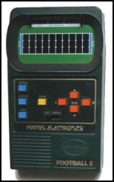
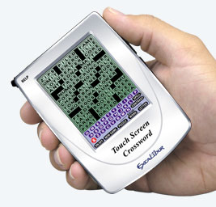
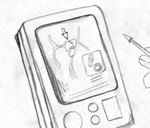

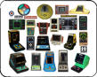
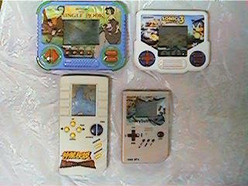
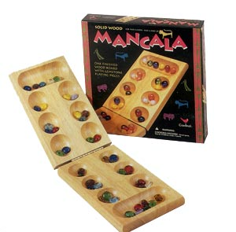
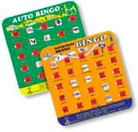
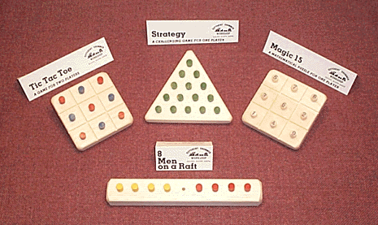
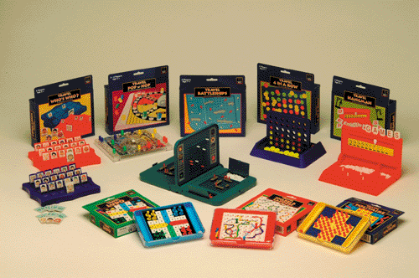
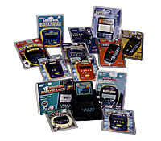
CLASSIC DESIGN LIFE CYCLE
BRIEF – Statement of Intent
RESEARCH – Gathering information
INITIAL IDEAS – Exploring solutions
DEVELOPMENT – Adding key details
SPECIFICATION – List of requirements
MAKING – Producing the prototype
EVALUATING – How are we doing? Intent

Hand Held
Game
Project

Name

Page of
Some Initial Ideas / Product Analysis

Hand Held Game
Aesthetics (Looks)
Features
Value for Money
Safety
Materials
No Sharp Edges
Funky / curved
Functional
Non Toxic
Single Game?
Max Selling Price £10?
pocket money?
Reuse as different product?
Self Coloured Plastic?
Levels of Difficulty
Yr10 Hand Held Electronic Game Assessment Sheet

Name

Brief:

Design and make a working hand held electronic game of the highest quality during the next 12 weeks which has the ability to be easily modified to execute different game programmes using basic components. There are limited resources available and these will need to be taken into account during both design and making stages. This project will follow a typical design cycle for GCSE coursework and will be assessed as below:

Ensure the following deadlines are adhered to:
End of Week 3 Research work to be handed in
End of Week 6 Design Development to be completed
End of Week 11 Prototype to be complete
End of Week 12 Final Complete Folio assessment

Assessment of Pupils ability to: |  |  | Mark
Design Stages
Provide a description of the key elements of existing hand held game designs using product analysis and questionnaires
Produce a range of solutions that reflects the design brief and incorporates elements from research
Develop a single solution, which satisfies all elements of the brief including and includes a making plan (equipment, materials, etc.)
Use of graphical communication / IT skills to convey ideas

Design Total (max 40)
Making Stages
Develop a clear plan for making the hand held game including materials, equipment, processes and quality checks required
Use of appropriate equipment and processes to safely manufacture the hand held game design case and working parts
Demonstrate the level of accuracy and finish required for the finished game to be desirable and fun to use
Evaluate, test and modify work throughout the designing and making process

Making Total (max 60)
Project Total (max 100)
Example of a Design Brief and Specification

Design Brief

“ To design and make a pen and storage unit for the home and office so that a pen is always available”

Specifications (in order of priority)

- the pen must be able to be used for writing
- the pen must be housed in a table top unit;
- the pen must be aesthetically suited to the user and his/her environment;
- the pen must be a single piece when not being used;
- the pen must consist of the minimum of removable parts;
- the pen must be able to house a standard biro refill;
- the refill must be able to be changed easily;
- there must be a means of protecting the nib when not in use;
- the length of the pen must not exceed 160mm;
- the maximum diameter of the pen must exceed 15mm;
- the pen must not leak;
- all moving parts must be concealed safely while allowing for maintenance;
- the pen must be comfortable to hold;
- the pen must be safe to use;
- the unit must not have any sharp edges;
- the pin tray must not mark the surface on which it stands;
- the pen set must blend in with its surroundings when empty of pins and when the pen is in use;
- the unit must use the minimum of materials to keep down costs;
- the pen unit must be robust;
- the pen unit must be made from non toxic materials;
- the unit must be stable;
- the pen must be easily removed from the unit
- the pen must be easily replaced into the unit;
- the cost of the materials must not exceed £10.00.

